IBP Turbot 2018

Executive summary

# Opening of the meeting

The meeting was opened at Monday the 30th of June by chairs José de Olivera and Alexander Kempf. The meeting was attended by the chairs, Jurgen Batsleer, Ruben Verkempynck, Lies Vansteenbrugge, Wouter van Broekhoven and Niels Hintzen and hosted at Wageningen Marine Research in IJmuiden, The Netherlands.

# Adoption of the agenda

The agenda was adopted and is given in Annex 2.

# Benchmark timeline

The 2015 Inter-benchmark for turbot in 27.4 ended with several issues left in the final SAM assessment. Among other things, the low quality of input data and a strong retro-pattern in F was highlighted. Finally, the assessment was accepted as category 3 assessment using the relative trends in SSB only (ICES 2:3 rule). During WGNSSK 2017 questionable model settings used since the 2015 Inter-benchmark were detected. This led to the decision that a further Inter-benchmark was needed before advice on turbot in 27.4 can be provided for 2018.

During the IBPtur27.4, all available input data were screened again including a new lpue index from UK, a delta-gam survey index combining several BTS surveys and for the first time age-based catch data from Denmark for most recent years. Also, different models to standardise the Dutch lpue time-series were tested. The SAM model settings were reviewed, and sensitivity runs were conducted with various combinations of input data, plus group settings, highest age used in survey indices and different length of the assessment time-series. Decisions were made on final input data and model settings.

In addition, reference points were estimated. IBPtur27.4 met by correspondence between July 2017 and September 2017. At WGNSSK 2018 a mistake was found in the IBP assessment configuration which led to questions on the persistence of the retrospective and assessment category used to provide advice. For this reason, an inter-benchmark was organised for 2018 to

1. Correct the mistake in the IBP2017 settings (using the NL LPUE series as an indicator of exploitable biomass rather than as an indicator of SSB)
2. Check the plus-group of the catch and survey data
3. Re-evaluate parameter bindings in the assessment configuration
4. Estimate reference points for either category I (using EQsim) or category III (using Spict)
5. Provide a short-term forecast

All code and results can be found at: <https://github.com/ices-eg/wg_IBPTur.27.4/IBP_2018/>

# Changes in Turbot assessment compared to 2017

The 2018 Inter-benchmark began by reviewing the mistake made in the 2017 Inter-benchmark, followed by a review of the plus group settings and highest age used in the survey indices as well as the configuration of model parameters.

To analyse the mistake a IBP2018 base run was set up, using similar settings to the IBP2017 base run, but including 2017 data. This IBP2018 base run was run setting the biomass treatment to 0 (i.e. SSB) or 2 (i.e. exploitable biomass, FSB). Next, the IBP2017 run and the WGNSSK2018 outcomes where compared to both IBP2018 runs (Figure 4.1). The results of the WGNSSK 2018 resembles the FSB 2018 run as they have similar settings and identical data input. The IBP 2017 and SSB 2018 runs look similar since they have the same settings for biomass survey treatment. Differences in the outcome occur due to different parameter settings and data input; the IBP 2017 run includes data up till 2016, while the SSB 2018 run includes one additional year of data.

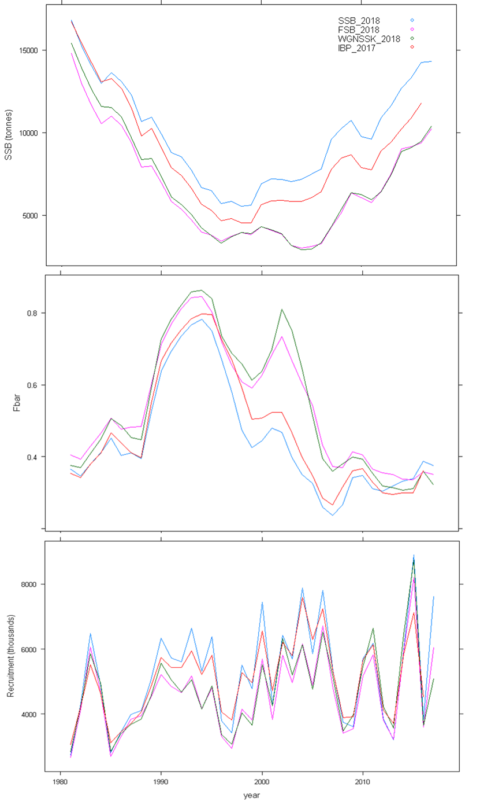

Figure 4.1:

**PG group and age of survey**

The 2018 Inter-benchmark reviewed the model settings and carried out several runs with various combinations of plus group settings and highest age used in the survey indices.

Decision for PG 9+ based on absolute values of Mohns rho.

|  |  |  |  |  |  |  |  |  |  |  |  |
| --- | --- | --- | --- | --- | --- | --- | --- | --- | --- | --- | --- |
|  |  | **10** | | **9** | | **8** | | **7** | | **6** | |
|  |  |  | Abs. |  | Abs |  | Abs |  | Abs |  | Abs |
| **Mohns rho** | *SSB* | -1.8 | 6.64 | -4.66 | 5.71 | -5.69 | 8.9 | -7.87 | 8.76 | -32.13 | 32.13 |
| *Fbar* | -3.05 | 9.47 | -0.89 | 7.77 | -2.56 | 11.45 | 0.04 | 9.04 | 14.99 | 15.77 |
| *rec* | 4.48 | 17.07 | 3.88 | 16.94 | 5.23 | 18.16 | 4.35 | 18.43 | -2.73 | 18.06 |
| *mean* | 3.11 | 11.06 | 3.14 | 10.14 | 4.49 | 12.84 | 4.08 | 12.08 | 16.62 | 21.99 |
| *sum* | 9.33 | 33.18 | 9.43 | 30.42 | 13.48 | 38.51 | 12.25 | 36.23 | 49.85 | 65.96 |

Table 4.1

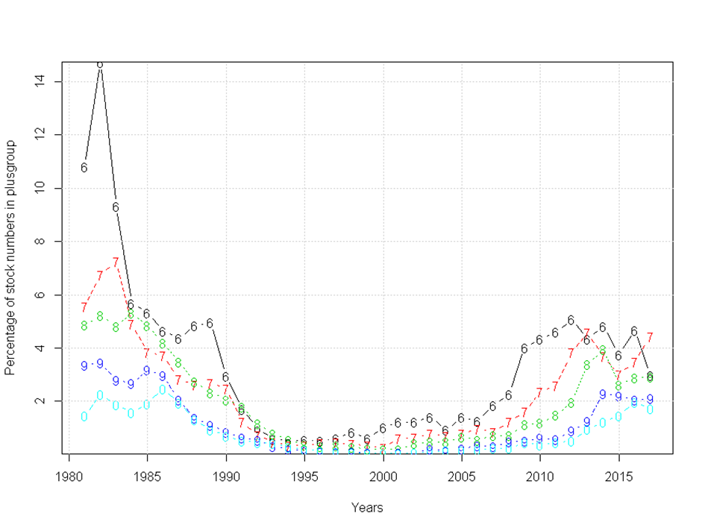

Figure 4.2: Percentage of stock numbers in the plus group

**Age of survey’s**

|  |  |  |  |  |  |  |  |  |  |  |  |
| --- | --- | --- | --- | --- | --- | --- | --- | --- | --- | --- | --- |
|  |  | **7** | | **6** | | **5** | | **4** | | **3** | |
|  |  |  | Abs. |  | Abs |  | Abs |  | Abs |  | Abs |
| **Mohns rho** | *SSB* | -0.31 | 7.70 | 0.51 | 7.63 | 0.56 | 5.84 | -0.17 | 5.62 | -0.50 | 5.89 |
| *Fbar* | -5.19 | 10.55 | -5.27 | 10.66 | -4.87 | 8.92 | -6.05 | 8.65 | -6.51 | 8.57 |
| *rec* | 0.73 | 17.15 | 0.17 | 17.01 | -0.89 | 16.95 | -0.80 | 16.25 | -0.14 | 17.04 |
| *mean* | 2.08 | 11.80 | 1.98 | 11.77 | 2.11 | 10.57 | 2.34 | 10.17 | 2.39 | 10.50 |
| *sum* | 6.24 | 35.40 | 5.94 | 35.30 | 6.32 | 31.70 | 7.01 | 30.52 | 7.15 | 31.50 |

Table 4.2

Decision is to keep 7 and 6 as max age for SNS and BTS respectively because the extra age group in BTS may provide more information in the long run if the stock keeps increasing.

**Parameter settings**

After setting the plus group and age in surveys, the SAM model configurations were determined. Model parameters were given the freedom where needed and were restrained when the AIC criteria indicated a more restrictive model was preferred. As such, (how many) sensitivity runs were performed to find an optimum in number of free parameters vs. model fit (AIC) and mohns rho (both being minimized) (table 4.3).

Table.....

|  |  |  |  |
| --- | --- | --- | --- |
| Parameter categories | IBP 2017 | IBP 2018 | SUMMARY |
| min age | 1 | 1 |  |
| max age | 8 | 9 | 9+ group has the lowest absolute Mohns rho |
| Fishing mortality states | 1 2 3 4 5 6 7 7 | 1 2 3 4 5 6 7 8 8 | Allowing maximum freedom, binding the last two ages. |
| correlated random walks | 2 | 2 | Same settings to 2017 based on lowest AIC |
| Coupling catchability  parameters |  |  |  |
| SNS | 1 1 2 3 3 3 0 0 | 1 1 2 3 3 3 0 0 | Same settings to 2017 based on lowest AIC |
| BTS | 4 4 5 5 6 6 6 0 | 4 4 5 5 6 6 6 0 | Same settings to 2017 based on lowest AIC |
| NL_LPUE | 7 0 0 0 0 0 0 0 | 7 0 0 0 0 0 0 0 | Same settings to 2017 based on lowest AIC |
| Coupling of fishing mortality RW | 1 1 2 2 3 3 3 3 | 1 2 3 3 4 4 4 5 5 | Additional parameters in the model compared to 2017, choice is based on lowest AIC value |
| Coupling of log N RW | 1 2 2 2 2 2 2 2 | 1 2 2 2 2 2 2 2 2 | Same settings to 2017 based on lowest AIC |
| Coupling of observation variances |  |  |  |
| Catch | 1 1 2 2 2 3 3 3 | 1 2 3 3 4 4 5 5 5 | More parameters in the model compared to 2017. Result is based on lower AIC in combination with better Mohns rho |
| SNS | 4 4 5 5 5 5 0 0 | 6 6 7 8 8 8 0 0 0 | Choice is made on improved AIC |
| BTS | 6 6 6 7 8 8 8 0 | 9 9 9 10 11 11 11 0 0 | Choice is made on improved AIC and Mohns rho as well as amount of parameters. |
| NL_LPUE | 9 0 0 0 0 0 0 0 | 12 0 0 0 0 0 0 0 0 |  |
| Stock–recruitment model | 0 (RW) | 0 (RW) |  |
| Coupling of survey correlation correction by age |  |  |  |
| Catch | 0 0 0 0 0 0 0 0 | 0 0 0 0 0 0 0 0 0 |  |
| SNS | 1 2 2 2 2 0 0 0 | 1 2 2 2 2 0 0 0 0 | Same settings to 2017 based on lowest AIC |
| BTS | 0 0 0 0 0 0 0 0 | 0 0 0 0 0 0 0 0 0 |  |
| NL_LPUE | 0 0 0 0 0 0 0 0 | 0 0 0 0 0 0 0 0 0 |  |
| Biomass treat | 0 (SSB) | 2 (exploitable biomass) | Use the NL LPUE series as an indicator of exploitable biomass rather than as an indicator of SSB |

**Table 4.3:**

# Reference points

Reference points were estimated using the R-script template provided by ICES which was developed early 2018 by D.C.M. Miller to ensure a correct procedure in estimating reference points was followed. The script used to estimate reference points can be found at the IBP github page.

The simulations were executed with the entire time-series of SR-pairs (including the most recent estimate of recruitment given that the SNS is a dedicated survey on juvenile flatfish in the coastal areas and is hence expected to provide accurate estimates of recruitment (correlation ~0.83)). In the period 1981-1986 the productivity of the stock was markedly lower than in more recent years but these years were included as it provided overall better fits to the stock-recruitment models (excluding would lead to near infinite steepness in the Beverton & Holt model). The simulations were run with 2000 iterations and applying a mixture of three SR-models, namely Segmented Regression, Ricker and Beverton & Holt. No clear a-priory The number of recent years to be used for weight-at-age and selectivity were set to 5 (excluding the most recent year), similar to the default settings. The cv on F, phi on F, cv on SSB, 5th percentile of SSB in the terminal year and phi on SSB were taken as the default values and obtained from the final year in the SAM assessment.

Blim was estimated using a segmented regression model with auto-correlation correction. No auto-correlation in recruitment was detected however. Bpa was derived multiplying Blim with exponent of sigmaSSB * 1.645. Flim derived from Blim by simulating the stock with segmented regression S-R function with the point of inflection at Blim. Flim = the F that, in equilibrium, gives a 50% probability of SSB > Blim. Btrigger was set to 0, Fcv, Fphi, SSBcv were set to 0 and rhoRec was set to FALSE. Fpa was derived multiplying Flim with the exponent of –sigmaF * 1.645.

The initial Fmsy was calculated including stochasticity in the population and exploitation as well as assessment/advice error. Btrigger was set to zero while Blim and Bpa were included. Since Fmsy was lower than Fpa, Fmsy was taken as the point estimate from the simulation.

MSY Btrigger was taken as the 5th percentile of SSB at MSY which was higher than Bpa. Finally, Fmsy was evaluated using the Btrigger estimate from the previous analysis.

The table below shows the estimated reference points using the final IBP 2018 assessment.

|  |  |
| --- | --- |
| Reference point | Estimate |
| 1. MSYBtrigger | 6396 |
| 1. Bpa | 3599 |
| 1. Blim | 2955 |
| 1. Fpa | 0.51 |
| 1. Flim | 0.62 |
| 1. Fp05 | 0.9 |
| 1. Fmsy | 0.37 |

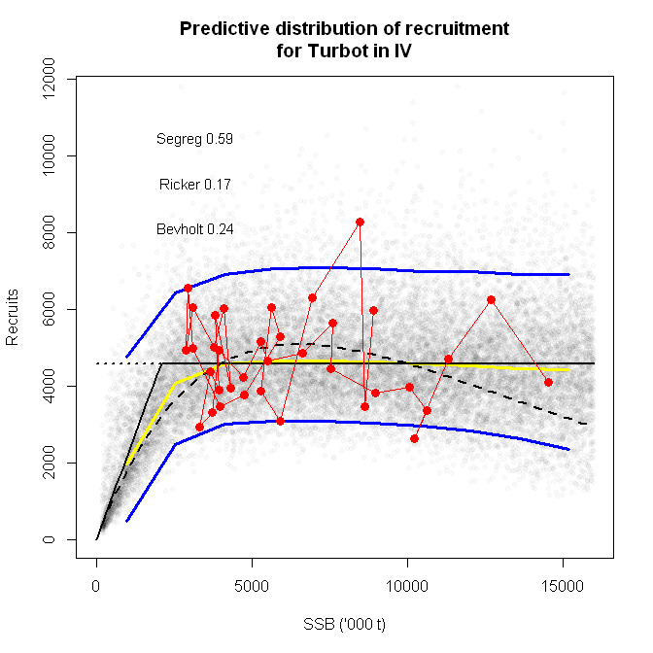

Figure 5.1. Fitted combinations of stock recruitment fits to the SR-couples of Turbot

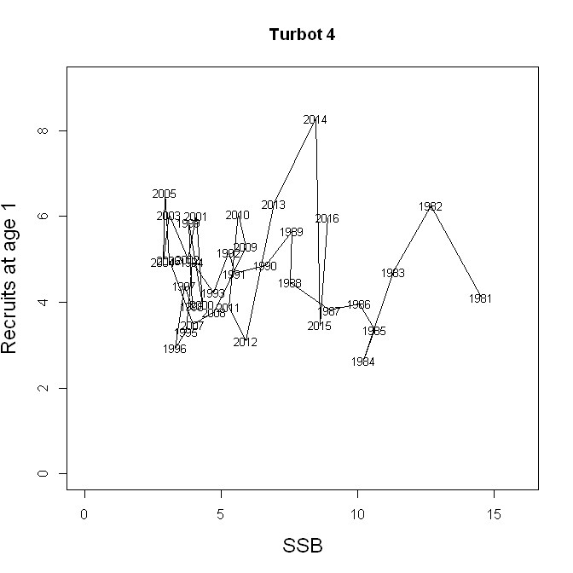

Figure 5.2 Stock recruitment pairs over time

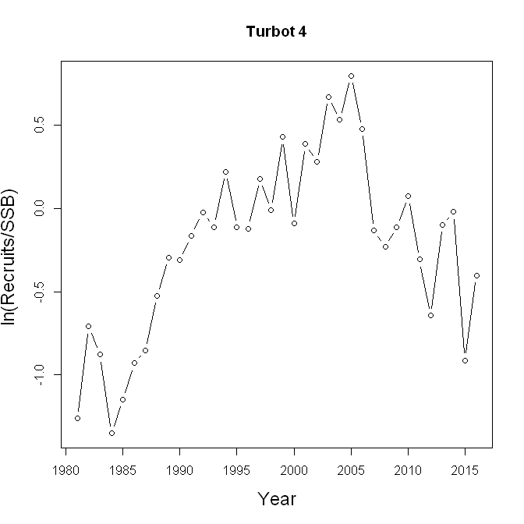

Figure 5.3. Productivity over time

# Short term forecast

The short-term forecast was implemented in FLR using the fwd-routines. Terminal year estimates from the SAM assessment were used as starting conditions. Since there is no clear relationship between SSB and Rec, it was chosen to assume recruitment to follow a geometric mean over the most recent 5 years, including the latest estimate. Weights-at-age, maturity-at-age, selection-at-age were taken as an normal average over the past 3 years. Weights are pre-smoothed during data preparation and as such a longer period is not justified. Selection-at-age is relatively stable but some clear changes are visible extending it backwards to e.g. 5 years. Maturity is fixed.

TACs for Turbot are agreed upon in combination with Brill. As such, the average proportion of Turbot landings out the TAC was calculated. Over the past 5 years (2013-2017) this averaged to 63%. It is here recommended to use the most recent 5-year period to derive the intermediate year catch for the Turbot forecast from the agreed total Turbot and Brill TAC.

No further assumptions had to be made and an example of a forecast table is given below.

Table 6.1. TAC and landings of Turbot and Bril. * denotes predicted value

|  |  |  |  |
| --- | --- | --- | --- |
| Year | TAC Tur & BLL | TUR landings | Proportion TUR landings |
| 2013 | 4642 | 3084 | 0.664368807 |
| 2014 | 4642 | 2871 | 0.618483412 |
| 2015 | 4642 | 2978 | 0.641533822 |
| 2016 | 4488 | 3147 | 0.701203209 |
| 2017 | 5924 | 3175 | 0.535955436 |
| 2018 | 7102 | 4491* |  |
| Mean |  |  | 0.632308937 |

Table 6.2 Turbot in Subarea 4. Assumptions made for the interim year and in the forecast.

| Variable | Value | Notes |
| --- | --- | --- |
| Fages 2–6 (2018) | 0.47 | Average exploitation pattern in 2015–2017, scaled to Fages 2‑6 in 2017 |
| SSB (2019) | 10163 | Short-term forecast (STF), in tonnes |
| Rage1 (2018) | 5070 | Geometric mean (GM, 2013–2017), in thousands |
| Rage1 (2019) | 5070 | Geometric mean (GM, 2013–2017), in thousands |
| Total catch (2018) | 4491 | Short-term forecast (STF), in tonnes, predicted from TAC usage in combined TAC with Brill |

Table 6.3 Turbot in Subarea 4. Annual catch scenarios. All weights are in tonnes.

| Basis | Total catch (2019) | ^^Ftotal ages 2–6 (2019) | SSB  (2020) | % SSB change ** | % TAC change *** | % Advice change ^ |
| --- | --- | --- | --- | --- | --- | --- |
| MSY approach: FMSY | 3219 | 0.37 | 8718 | -0.2 |  | -35 |
| F = 0 | 0 | 0 | 12180 | 39.4 |  | -100 |
| Fpa | 4177 | 0.51 | 7708 | -11.8 |  | -15.7 |
| Flim | 4850 | 0.62 | 7007 | -19.8 |  | -2.1 |
| SSB (2020) = Blim | 8921 | 1.69 | 2955 | -66.2 |  | 80.1 |
| SSB (2020) = Bpa | 8243 | 1.43 | 3599 | -58.8 |  | 66.5 |
| SSB (2020) = MSY Btrigger | 5441 | 0.723 | 6396 | -26.8 |  | 9,9 |
| Rollover advised TAC | 4952 | 0.64 | 6901 | -19.8 |  | 0 |

** SSB 2020 relative to SSB 2019.

*** Total catch in 2019 relative to ...

Annex 1: List of participants

|  |  |  |  |
| --- | --- | --- | --- |
| Name | Institute | Country (of institute) | Email |
|  |  |  |  |
|  |  |  |  |
|  |  |  |  |
|  |  |  |  |
|  |  |  |  |
|  |  |  |  |
|  |  |  |  |
|  |  |  |  |
|  |  |  |  |
|  |  |  |  |
|  |  |  |  |
|  |  |  |  |
|  |  |  |  |
|  |  |  |  |
|  |  |  |  |
|  |  |  |  |
|  |  |  |  |
|  |  |  |  |
|  |  |  |  |
|  |  |  |  |
|  |  |  |  |

Annex 2: Agenda

Annex 3: WGXXX terms of reference for the next meeting

**Please use the example below to formulate your draft resolutions** **for next year’s meeting.**

The **Working Group on Fishing Behaviour** (WGFB), chaired by Anders Inglis, Sweden, will meet in Bruges, Belgium, 10–14 April 2011 to:

1. Review and consider recent research into unaccounted mortality in commercial fisheries;
2. Review ongoing work for reducing unintended effects on the seabed and associated communities of fishing operations and gears, including ghost fishing.

WGXXX will report by DATE to the attention of the XXXXX Committee.

Supporting Information

|  |  |
| --- | --- |
|  |  |
| Priority | The current activities of this Group will lead ICES into issues related to the ecosystem affects of fisheries, especially with regard to the application of the Precautionary Approach. Consequently, these activities are considered to have a very high priority. |
| Scientific justification | Term of Reference a)  Several countries are conducting or have recently completed significant studies in this area and the subject would benefit from a review of progress and an evaluation of the results obtained. The last review of significant studies occurred in 1996 by the ICES Study Group on Unaccounted Mortalities. A review of more recent work will determine the need for revision and update on planning and methodology for studying this subject.  Term of Reference b)  All fishing activities have influences that extend beyond removing target species. The approach recommended by FAO is that responsible fisheries technology should achieve management objectives with a minimum of side effects and that they should be subject to ongoing review. WGFTFB members and others are currently undertaking a range of research programmes to provide the means to minimize side effects. |
| Resource requirements | The research programmes which provide the main input to this group are already underway, and resources are already committed. The additional resource required to undertake additional activities in the framework of this group is negligible. |
| Participants | The Group is normally attended by some 20–25 members and guests. |
| Secretariat facilities | None. |
| Financial | No financial implications. |
| Linkages to advisory committees | There are no obvious direct linkages with the advisory committees. |
| Linkages to other committees or groups | There is a very close working relationship with all the groups of the Fisheries Technology Committee. It is also very relevant to the Working Group on Ecosystem Effects of Fisheries. |
| Linkages to other organizations | The work of this group is closely aligned with similar work in FAO and in the Census of Marine Life Programme. |

Annex 4: Recommendations

Recommendations are requested from Expert Groups to ensure that other Expert Groups, the ICES Secretariat, ICES Data Centre, ACOM or SCICOM are aware of information from the Expert Group that influences work in other parts of the ICES network. Expert Group Chairs are encouraged to upload recommendations online: <http://community.ices.dk/admin/Recomendations/SitePages/Home.aspx>. Recommendations are handled centrally to ensure that recommendations receive careful and equitable review.

Recommendations and their implications should be carefully considered by the Expert Group before submission and should relate to issues that the ICES network has the capacity to address. As a guide, Expert Groups should list up to a maximum of *five* Recommendations that they deem to be of high priority. Each year, prior to the ASC, the ICES Secretariat extracts all recommendations from Expert Group reports and transfers them to a spreadsheet for systematic review, by the ACOM and SCIOM Chairs and the Secretariat in the first instance. Please apply the following guidelines when developing and writing recommendations:

* Include a clear action that the ICES Secretariat, ICES Data Centre, ACOM or SCICOM can consider. For example:
  + To establish an Expert Group (these also require draft resolutions, which must be included in a separate annex of the report);
  + To propose a ToR for another ICES Expert Group (draft the ToR and name the receiving Expert Group);
  + To propose a Theme Session for an ASC (Theme Session proposals must also be submitted in response to the call for proposals distributed by the Secretariat in Spring);
* Spell out any acronyms used.
* Make it clear that it is the Expert Group (not ICES) presenting the recommendation.

Recommendations can be addressed to one or more of the following: other Expert Groups, ICES Secretariat, ICES Data Centre, ACOM, or SCICOM. Recommendations not addressed to one or more of these bodies are not processed. In the event an Expert Group identifies another issue of high importance or urgency that cannot be addressed through the recommendations process then it should be raised directly with ACOM and/ or the relevant Steering Group Chair.

Please **do not**:

* Address recommendations to “ICES” or “ICES Member Countries”;
* Include recommendations for the originating Expert Group. These should be recorded in a separate action list or included as ToRs in the draft Resolutions for the following year.
* Include recommendations giving advice.
* Request funding or ask that other funding agencies should support Expert Group work.

|  |  |
| --- | --- |
| Recommendation | Adressed to |
| 1. |  |
| 2. |  |
| 3. |  |
| 4. |  |
| 5. |  |